**GARAGE MANAGEMENT SYSTEM**

# Project Overview

This project is focused on developing a Garage Management System designed to streamline the day-to-day operations of an automotive repair shop. The goal is to create an efficient, user-friendly system using Salesforce to manage appointments, inventory, customer data, billing, and vehicle services. This project will enhance operational efficiency, improve customer experience, and support long-term growth for the garage by utilizing cloud-based CRM tools.

# Objectives

List the specific, measurable goals the project intends to achieve. Examples:

**Business Goals:**

* Improve appointment scheduling efficiency and reduce customer wait times.
* Enhance inventory accuracy to prevent stock-outs and over-ordering.
* Provide clear, data-driven insights into garage performance and customer satisfaction.

**Specific Outcomes:**

* A custom solution for managing vehicle service records, inventory, and billing.
* Automated workflows for updating inventory and notifying customers.
* Interactive dashboards to track garage performance metrics.

# Salesforce Key Features and Concepts Utilized

* **Custom Objects and Fields:** To manage data for vehicles, customers, service details, and inventory.
* **Role-Based Access Control:** Ensures only authorized users can access sensitive data.
* **Automation Tools:** Salesforce Flows and Process Builder automate appointment reminders and inventory management.
* **Reports & Dashboards:** Provide insights into garage activities, such as parts usage and revenue.

# Detailed Steps to Solution Design

* **Data Model:** Define entities like Customer, Vehicle, Service Record, and Inventory Item.
* **User Interface:** Create custom page layouts for service scheduling and customer check-ins.
* **Business Logic:** Set up Process Builder and Flow to automate notifications and inventory updates.
* **Screenshots:** Include relevant screenshots of custom objects, fields, and automation workflows to illustrate each design element.

**APP LAUNCHER :**

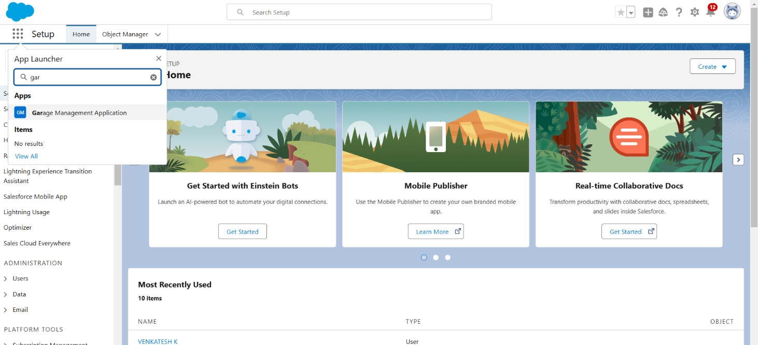

**GARAGE MANAGEMENT SYSTEM :**

* 1. **Customer Details**

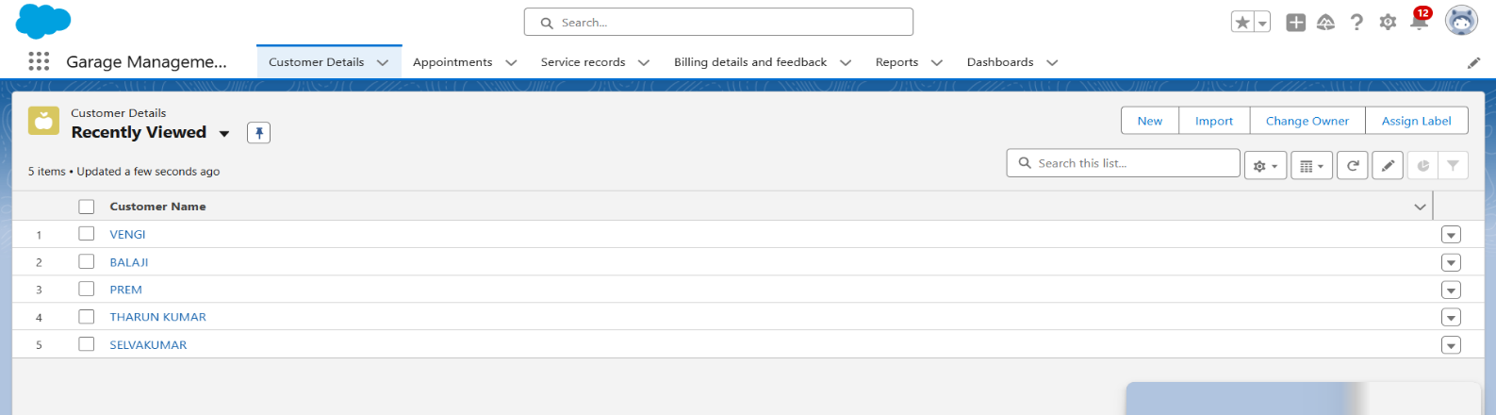

* 1. **Appointments**

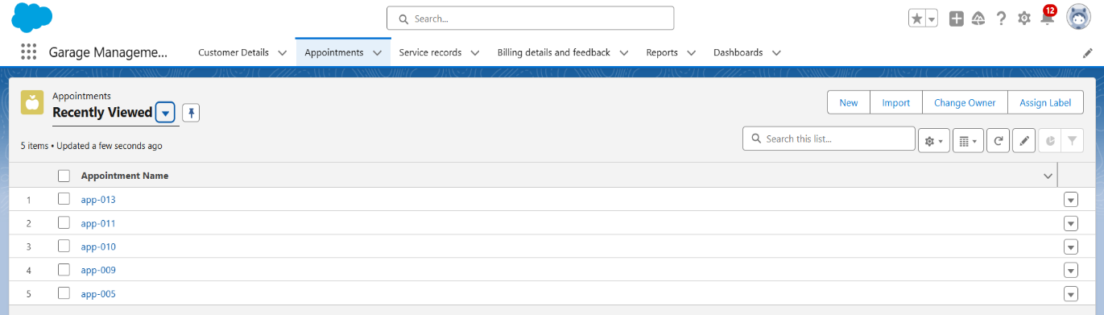

* 1. **Service Record**

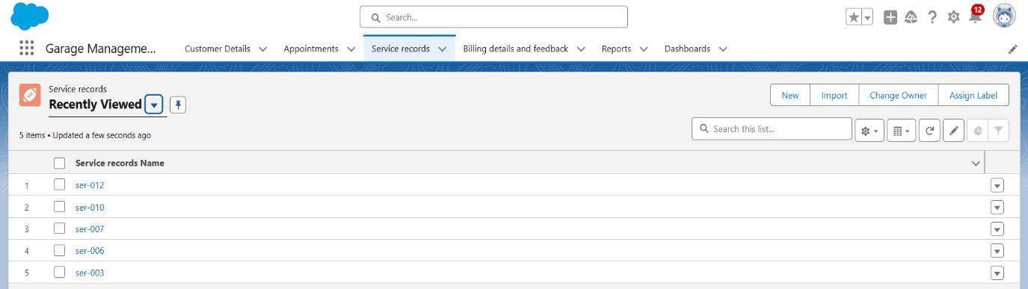

* 1. **Billing details and feedback Object**

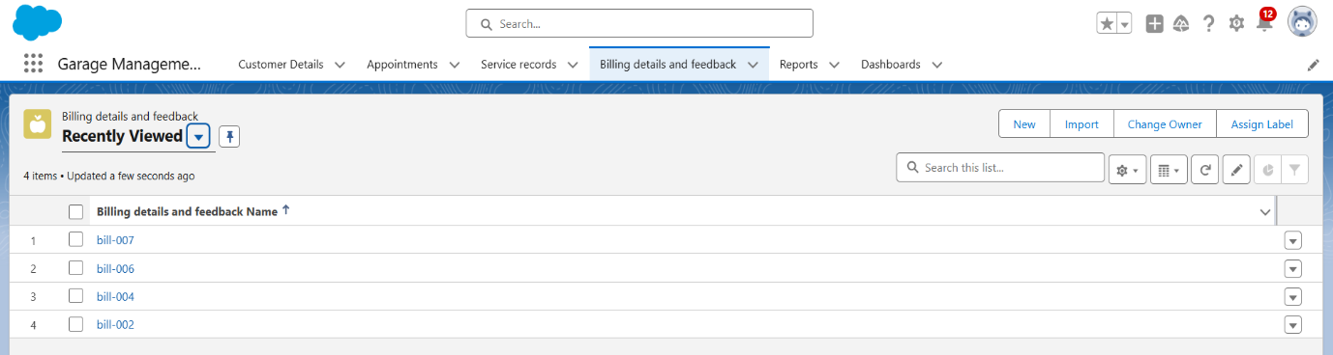

* 1. **Reports**

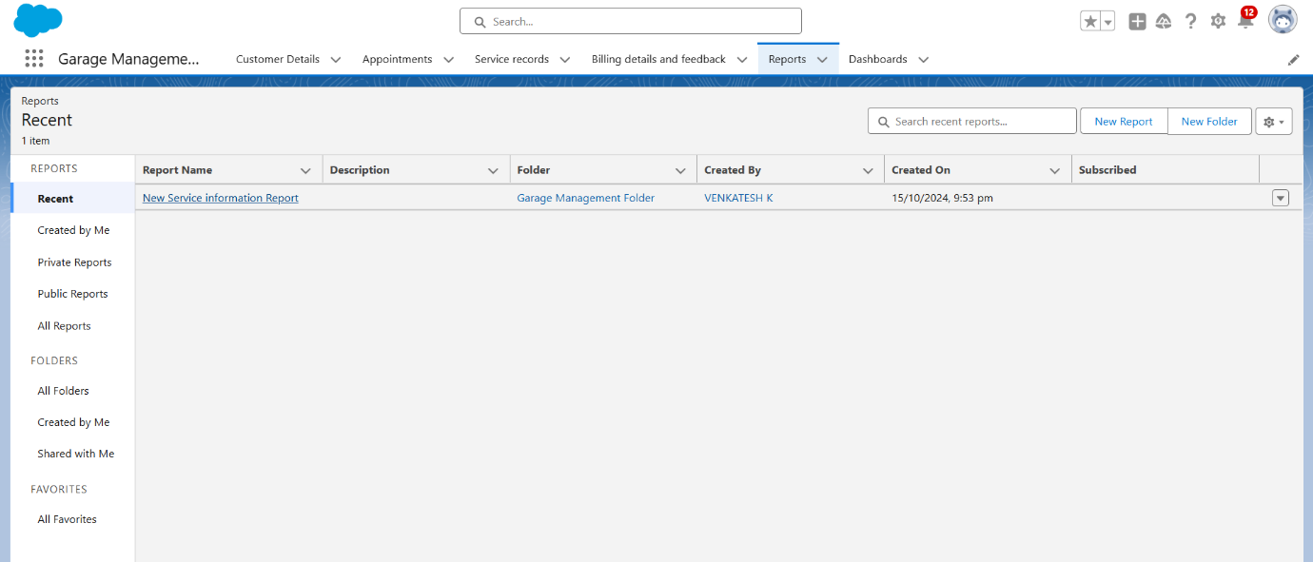

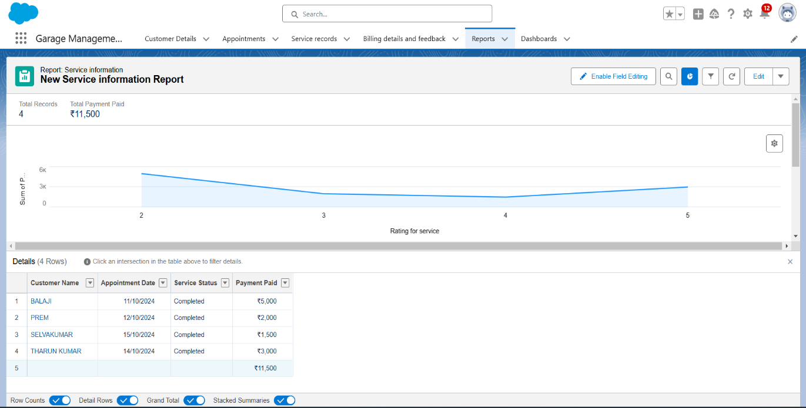

* 1. **Dashboards**

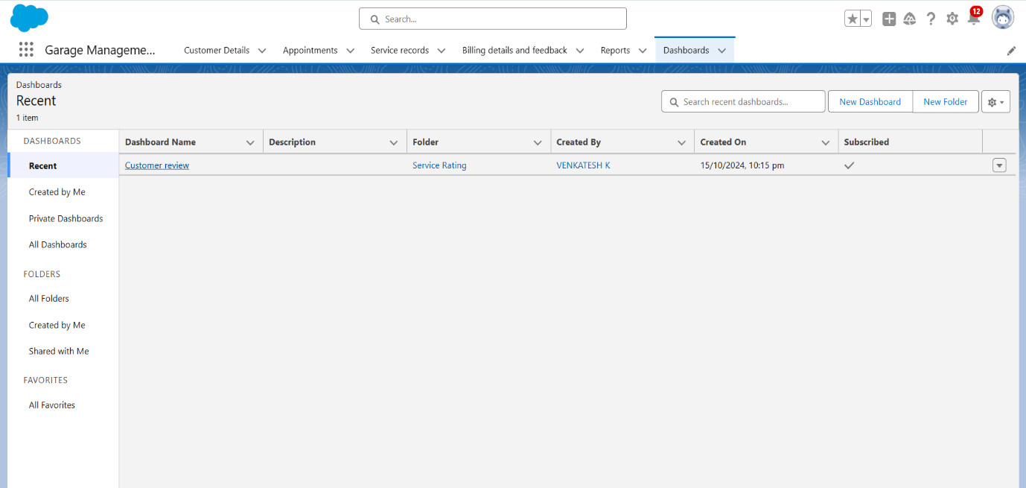

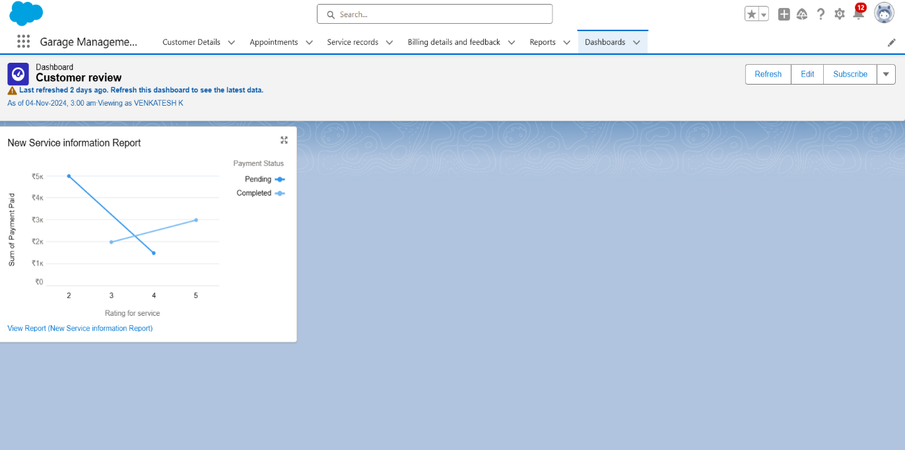

# Testing and Validation

* **Unit Testing:** Test Apex classes and triggers to ensure business logic works as intended.
* **User Interface Testing:** Validate that all user roles have access to appropriate fields and functionality.

# Key Scenarios Addressed by Salesforce

* **Appointment Management**: Enables easy scheduling, reminders, and rescheduling for customers.
* **Inventory Control**: Automates parts tracking and reordering.
* **Billing and Invoicing**: Simplifies invoicing and keeps financial records up-to-date.

# Conclusion

# Summary of Achievements:

# The Garage Management System project successfully delivered a customized solution that manages all core garage operations in a single platform. The system’s automation and data tracking capabilities have greatly improved workflow efficiency and customer satisfaction, supporting scalable growth for the garage.